BABEŞ-BOLYAI UNIVERSITY CLUJ-NAPOCA

FACULTY OF MATHEMATICS AND COMPUTER SCIENCE

SPECIALIZATION COMPUTER SCIENCE

DIPLOMA THESIS

Hidden Messages Using Image Steganography

Supervisor

Prof. Dr. Crivei Septimiu

**Author**

**Moisuc Naomi**

**2019**

UNIVERSITATEA BABEŞ-BOLYAI CLUJ-NAPOCA

FACULTATEA DE MATEMATICĂ ȘI INFORMATICĂ

SPECIALIZAREA INFORMATICĂ

LUCRARE DE LICENȚĂ

Ascunderea mesajelor în imagini folosind steganografia

Conducător Științific

Prof. Dr. Crivei Septimiu

**Absolvent**

**Moisuc Naomi**

**2019**

Table of Contents

**1. Introduction6**

**2. Cryptography7**

2.1 Overview7

2.2 Symmetric-Key Block Ciphers10

2.2.1 Symmetric-Key Encryption10

2.2.2 Block Ciphers12

2.3 Advanced Encryption Standard (AES)14

**3. Steganography16**

3.1 Overview16

3.2 Steganography vs. Cryptography 17

3.3 Steganography Types17

3.3.1 Pure Steganography17

3.3.2 Public Key Steganography18

3.3.3 Secret Key Steganography19

3.4 Characterization of Steganography Systems19

3.4.1 Capacity19

3.4.2 Robustness20

3.4.3 Undetectable20

3.4.4 Invisibility20

3.4.5 Security20

3.5 Steganography Techniques21

3.5.1 Substitution Systems21

3.5.2 Transform Domain Techniques23

3.5.3 Spread Spectrum Techniques23

3.5.4 Distortion Techniques24

3.5.5 Cover Generation Techniques24

3.5.6 Statistical Steganography24

3.6 Image Steganography25

3.6.1 Prior Work25

3.6.2 Problem Space26

3.6.3 Data Hiding in Still Images27

3.6.4 Low Bit Rate Data Hiding27

3.6.5 High Bit Rate Coding29

3.6.6 Applications30

**4. Architecture and Implementation32**

4.1 Overview32

4.2 Technologies34

4.3 Use Cases36

4.4 Event Scenarios38

4.5 Server Side40

4.5.1 Implementation of Steganography41

4.5.2 Implementation of Cryptography43

4.6 Client Side45

**5. Results46**

5.1 Hide46

5.2 Extract49

**6. Conclusions and Real-World Applications51**

**Bibliography52**

**1. Introduction**

There has always been a need for security. From ancient times people felt the need to be secure and started building means of defense against attacks, whether coming in the form of wild animals, other people invading their land or even the uncertainty of the next day. Since then, this need started to come in many different aspects. In the modern days, there is meaningful pressure when it comes to personal information security. People’s private data must be managed in such ways that it does not end up in the hands of malicious people. For most people, the internet might seem secure and they might not give a great deal of significance on their personal data such as email and passwords. But for those who understand how internet works, security might seem just an attribute for something that is not breakable, yet. Emphasizing the word “yet”, we can agree that methods which try to keep data secure must be continuously improved such that the attackers would not have enough time to break it, because it will be already changed and more powerful. When it comes to data security, nothing can be too secure or secure enough.

Some ways for keeping and transferring data in a secure way is by using methods such as Cryptography or Steganography. This paper focuses on how to use both Cryptography and Steganography for a more powerful result and also tries to improve the Steganography part by adding an extra 8-bit key. In addition to this, it also tries to make it easy for ordinary people to understand these two abstract concepts by presenting and explaining how to use an application that provides a simple and user-friendly way to encrypt and hide messages in images. There will be an overview on both Cryptography and Steganography, followed by a method on how to combine and improve these two. Some results and tests will be shared and analyzed and then we will come to conclusions.

**2. Cryptography**

**2.1 Overview**

Cryptography is the science of secret writing, a method of protecting communication and information using codes so that it can be read and process only by those for whom the information is intended. In computer science, cryptography refers to techniques coming from mathematical concepts and algorithms to transform messages in a way that is hard to decipher. These deterministic algorithms are used for web browsing on the internet and confidential communications such as email and credit card transactions, digital signing and verification to protect data privacy. Cryptography is all about preventing and detecting cheating and other malicious activities. [5][8]

The main goal of cryptography is to adequately address both in theory and in practice the following principles: confidentiality, data integrity, authentication and non-repudiation.

* **Confidentiality**

This service assures that the content of information will be kept from all but those authorized to have it. There are many approaches to providing confidentiality, also known as secrecy, from physical protection to mathematical algorithms which render data unintelligible.

* **Data integrity**

This service addresses the unauthorized alteration of data. To assure data integrity, one must have the ability to detect if an unauthorized party manipulates the data by inserting, deleting or substituting.

* **Authentication**

This service is related to identification and is applied to both entities and information. If two parties enter into a communication, they should identify each other and also the information delivered over a channel should be authenticated as to origin, date of origin, time sent, data content and others. Therefore, the authentication is subdivided into two major classes: data origin authentication and entity authentication. If a message is modified, it means that the source has changed; hence data origin authentication implicitly provides data integrity.

* **Non-repudiation**

This service prevents an entity from denying previous commitments or actions. When a dispute arises due to an entity that denies that some specific actions were taken, a procedure involving a trusted third party is needed to resolve the situation. For example, one entity that authorized the purchase of property by another entity might deny later that such authorization was granted.

There are many cryptographic tools, known as primitives, used to provide information security, such as encryption schemes, digital signature schemes and hash functions. Figure 2.1 provides a schematic list of primitives and how they are related. [5][8]

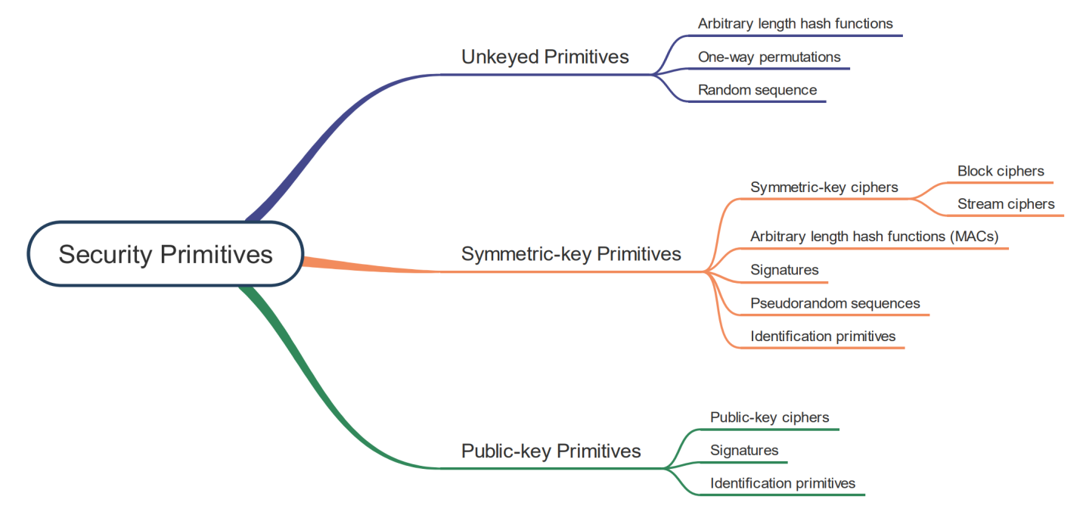

*Figure 2.1 Cryptographic Primitives*

These primitives are evaluated with respect to various criteria such as level of security, functionality, methods of operation, performance and ease of implementation.

* **Level of security**

This criterion is usually difficult to quantify. It is given by the number of operations required using the best methods currently known to defeat the intended objective. Usually, the level of security is given by the work factor, which is defined by an upper bound on the amount of work necessary to defeat the objective.

* **Functionality**

Usually, primitives are combined to meet various information security objectives. The basic properties of the primitives determine which ones are most effective for a given objective.

* **Methods of operation**

When a primitive is applied in various ways and with various inputs, it will typically show different characteristics. Therefore, depending on the mode of operation or usage, one primitive can provide very different functionality.

* **Performance**

This criterion is related to the effectiveness of a primitive in a specific mode of operation. For example, an encryption algorithm can be evaluated by the number of bits per second which can be encrypted by it.

* **Ease of implementation**

This criterion is related to the difficulty of realizing the primitive in a practical instantiation. This could include how complex the implementation of a primitive is in either a software or hardware environment.

The importance of various criteria is relative to the application and resources available. For example, if there is an environment where computing power is limited, the high level of security might be traded off for a better performance of the system as a whole.

Over the ages, cryptography has been an art practiced by many who have developed ad hoc techniques to meet some of the requirements for information security. [5][8]

**2.2 Symmetric-Key Block Ciphers**

**2.2.1 Symmetric-Key Encryption**

Symmetric encryption is a type of encryption that uses only one secret key for both encrypting and decrypting electronic information. The communicating parties must exchange the key so that the decryption process can be done. The difference between symmetric-key encryption and asymmetric-key encryption is that for the second one, a pair of keys, one public and one private, is sed to both encrypt and decrypt messages. [9]

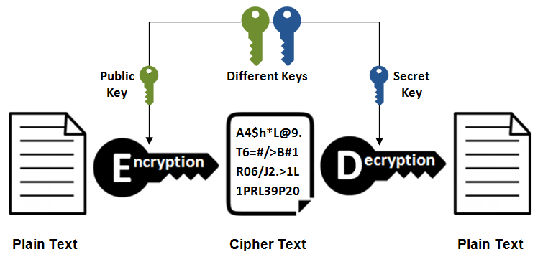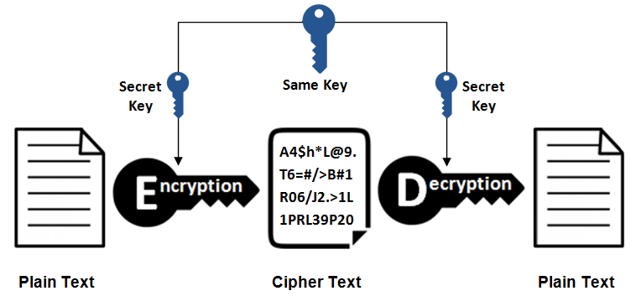

*Figure 2.3 Asymmetric Encryption [10]*

*Figure 2.2 Symmetric Encryption [10]*

When using symmetric-key encryption, the message is converted to a form that cannot be understood by someone who does not possess the secret key to decrypt it. Once the intended receiver who possesses the secret key has the data, the algorithm returns the message to the original one by reversing the action so that it can be understood. This secret key used by the sender and receiver can be a specific password, code or it can be a random string of letters and numbers that have been generated by a random number generator that is secure.

There are two types of symmetric-key encryption algorithms: block algorithms and stream algorithms.

* **Block algorithms.** With the use of a specific secret key, set of bits are encrypted in blocks of electronic data. The system holds the data in its memory while the data is being encrypted, so it waits for complete blocks.
* **Stream algorithms.** Instead of retaining the encrypted data in the memory of the system, stream algorithms hold it in streams.

Even if symmetric encryption is an older method of encryption, it is more efficient and faster than asymmetric encryption. Therefore, it is usually used for encrypting large amounts of data such as databases. For a database, the secret key for encryption and decryption might be available only to the database itself. Symmetric cryptography is also used in payment applications, such as card transactions where PII needs to be protected for preventing fraudulent charges or identity theft. Other examples for the usage of this encryption are validation to confirm that the sender of a message is who he claims to be and for random number generation or hashing. [9]

**2.2.2 Block Cipher**

A block cipher is a function which maps plaintext blocks of n-bits to cipher-text blocks of n-bits. This function encrypts or decrypts its input not one bit at a time, but one block at a time using a secret shared key. Usually the block is fixed in size, or padding is added if necessary. When encrypting, block cipher uses the shared key to transform its plaintext input into an encrypted text, cyphertext. When decrypting, the function uses the same key for transforming the cyphertext back to the original one. Therefore, the length of the input is the same as the length of the output. [5][7]

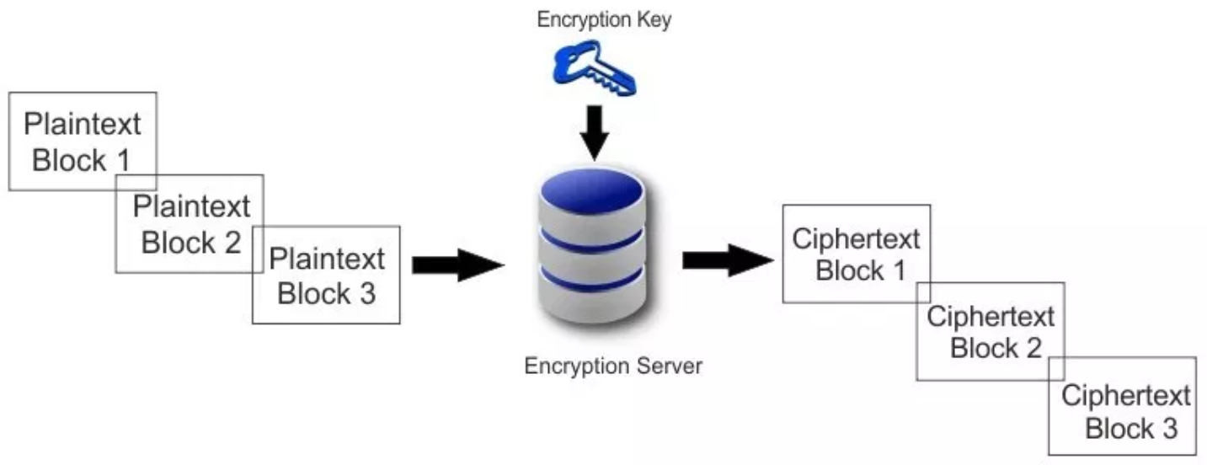

*Figure 2.4 Block Cipher [12]*

In many cryptographic systems, symmetric block ciphers are the most prominent and significant elements because individually, they provide confidentiality. These ciphers are fundamental building blocks with a versatility that allows building of pseudorandom number generators, hash functions and stream ciphers. Furthermore, they may serve as a central component in entity authentication protocols, message authentication techniques and digital signature schemes and data integrity mechanisms. [9]

Although if a block cipher offers a high level of security, it might not be ideally suited for all applications. In practical applications, there are inevitable required tradeoffs that contribute to a cipher not being suitable for it. Some tradeoffs can be different tolerances of applications to properties of various modes of operation, speed requirements and memory limitations such as code size, data size and cache memory and constraints imposed by implementation platforms such as hardware, software and chipcards. Furthermore, the efficiency usually must be traded off for security. Therefore, it is necessary to have a number of candidate ciphers from which to choose. [9]

Some examples of symmetric-key block ciphers are: AES (Advanced Encryption Standard), DES (Data Encryption Standard), IDEA (International Data Encryption Algorithm), Blowfish (Drop-in replacement for DES or IDEA), RC5 (Rivest Cipher 5), RC6 (Rivest Cipher 6). [9]

**2.3 Advanced Encryption Standard (AES)**

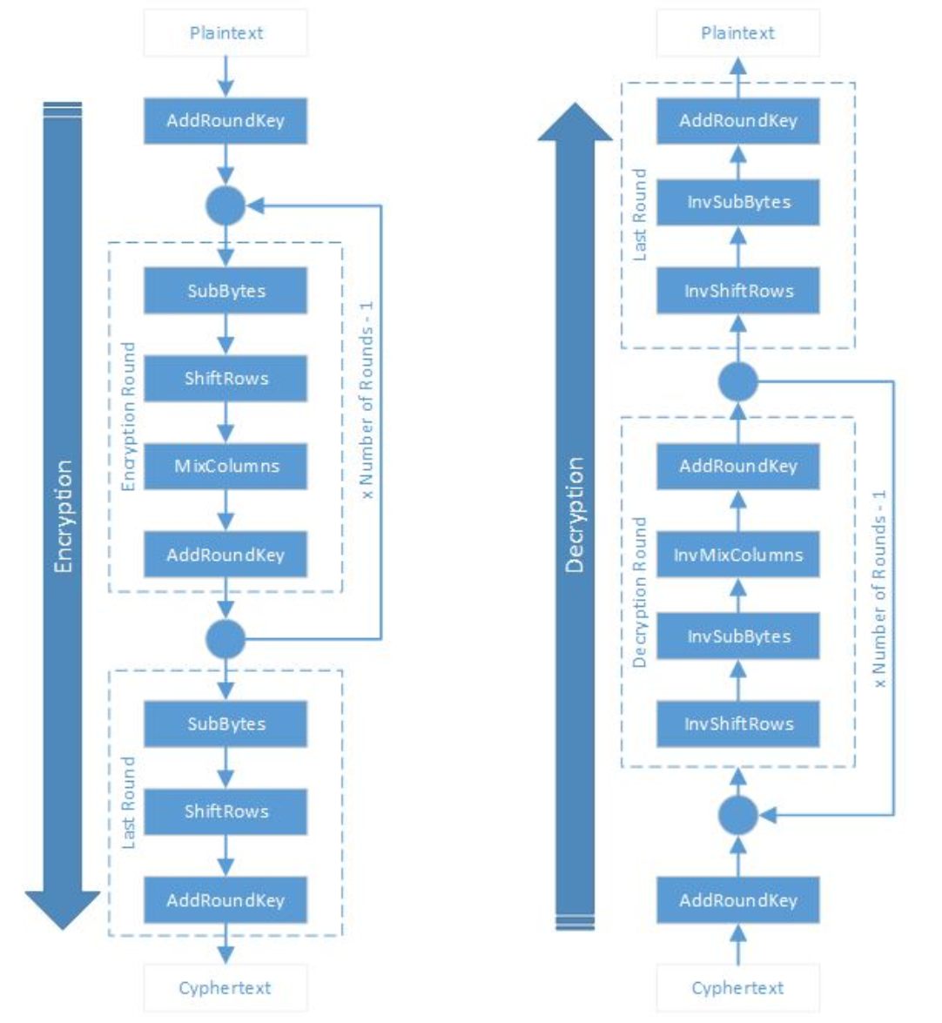Advanced Encryption Standard is a more widely and popular adopted symmetric encryption algorithm encountered nowadays. It is a symmetric key block cipher with a block length of 128 bits. It allows using different key lengths such as 128, 192 and 256 bits. The algorithm for encrypting and decrypting consists of several rounds of processing. The number of rounds depends on the length of the key as it follows: 10 rounds for keys of 128 bits, 12 rounds for keys of 192 bits and 14 rounds for keys of 256 bits. All the rounds are identical, except for the last one. A round consists in four steps: byte substitution, shift rows, mix columns and add round key. The mixing of the columns is not performed in the last round. The order of the steps is different for encryption and decryption. [3][4]

*Figure 2.5 AES Encryption and Decryption [4]*

* **Byte Substitution (SubBytes)**

The 16 bytes received as input are substituted with the elements from a fixed table (S-box) given in design. A matrix of four rows and four columns will contain the result.

* **ShiftRows**

This function shifts to the left each of the four rows of the matrix. Any element that is at the most left position will be inserted at the end of the row. The first row will remain the same, the second row will be shifted one position to the left, the third one will be shifted two positions to the left and the fourth row will be shifted three positions to the left. A new matrix with four rows and four columns will have the same 16 bytes of result but shifted.

* **MixColumns**

This function transforms each column of four bytes using a special mathematical function. The bytes are transformed in completely new bytes that will replace the original column. The result is again a matrix with four rows and four columns containing 16 new bytes. This step is not executed in the last round.

* **AddRoundKey**

This function takes the 16 bytes from the matrix and considers them as 128 bits. An XOR operation is made with these bits and the 128 bits of the round key. In the last round, these bits will be the actual ciphertext. If there are more rounds, these bits will be interpreted again as 16 bytes and the next round will begin.

Advanced Encryption Standard is widely adopted and supported in present day cryptography, in both software and hardware. No practical cryptanalytic attacks against the abstract attacks have been discovered until now, but there are practical side-channel attacks against implementation of AES. Moreover, AES provides a flexibility of the length of the key that is built-in. However, the security of AES is assured only if it is correctly implemented and if there is a good management of the key. [3][4]

**3. Steganography**

**3.1 Overview**

Steganography is the art of hiding and transmitting data through seemingly harmless carriers in an effort to hide the existence of the data. It has been used since ancient history and an early example of it is how Demartus of Greece informed Sparta that Xerces the King of Persia was planning to invade. As wooden tablets covered in wax were used for writing text, Demartus decided to hide the information behind the wax. He scraped the wax from the tablet, engraved the message and covered the tablet back with wax. In this way he managed to conceal this important information so that the tablets could pass the inspection as they left Persia by courier for Greece. Another technique of hiding the information was invented by the Germans in World War II, the use of microdots. Microdots were very small images with messages that were at the size of a printed period and it was possible to read the text only when magnified. This is how the Germans were able to hide important war information in random letters as periods. Another method, ingenious as well, was to hide the message directly in the messenger. This implied to shave the messenger’s head, tattoo his head with the information and then let his hair grow back again before sending him to deliver the message. [15][2]

Steganography has its place in security, not to replace cryptography, but to reduce the chance of messages to be detected by hiding the information. Cryptography and Steganography are combined in some Steganographic methods for offering an extra layer of protection to the encrypted message. Knowing that it is harder for the attacker to detect hidden cipher text in a cover, the message is encrypted prior to sending it. Even if Steganography and Cryptography are related and used together, there are actually fundamentally different. [15][2]

**3.2 Steganography vs. Cryptography**

Cryptography is the practice of “scrambling” messages to make them very difficult to decipher even if they are detected. Steganography has as purpose to conceal the message so that its very existence is hidden. It doesn’t matter how well concealed a message is, there is always the possibility of finding it. And even with the use of the strongest encrypting algorithm, if encrypted information is found, it is going to be subject of cryptanalysis. Therefore Cryptography and Steganography are mutually exclusive technologies. But these two combined offer a highly secured technique that conceals the existence of an encrypted message. In doing this, an encrypted message will be far less likely to be discovered and if a message concealed through Steganography is discovered, there is still the deciphering task that needs to be completed. [15][2]

**3.3 Steganography Types**

Any communication between people and organizations should be secure, even if it is through the use of phone, radio or computer communication. There are basically three types of Steganography: Pure Steganography, Public key Steganography and Secret key Steganography.

**3.3.1 Pure Steganography**

The Steganography system that doesn’t require prior exchange of some secret information before sending the message it is called a Pure Steganography system. Therefore this system depends entirely on its secrecy because to start the communication process there is no need of required information. The pure Steganography can be defined as the quadruple (C, M, D and E) where:

* C is the set of possible covers.
* M is the set of secret massage with |C| ≥ |M|.
* E is C×M→C the embedding function.
* D is C→M of the extraction function with the property that
* 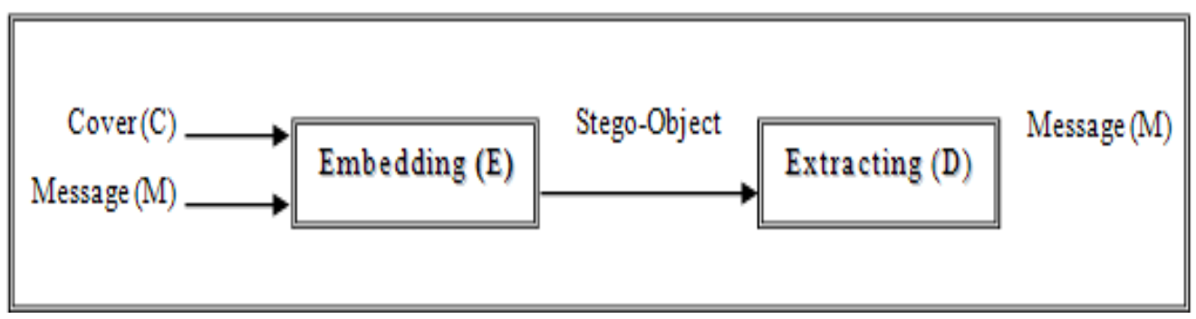D is (E(c, m)) =m for all m Є M and c Є C.

*Figure 3.1 Pure Steganography [15]*

If an attacker knows the embedding method then a pure Steganography protocol doesn’t provide any security. Considering all these, pure Steganography is preferred in most applications because no stego-key needs to be shared between the communicating parties. [15][2]

**3.3.2 Public Key Steganography**

The public key Steganography system requires a public key and a private key. The public key it is stored in a public database while the private key it is used to conceal the information and to extract the secret message. Therefore the public key Steganography system doesn’t require a secret key exchange. One example of how this system can be built is by using a public key crypto system. Before the imprisonment, the two communication partners can exchange public keys of some public key cryptography algorithms. The hidden information is being passed through public channels known by the receiver so that no one can know if there is concealed information within it or not. But if the receiver tries to extract the message from it using his private key, then it can be decrypted using the public key and the real message from the sender will be revealed. [15][2]

**3.3.3 Secret Key Steganography**

Secret key Steganography system requires a private key known by both the sender and the receiver. This key is used to embed the secret message into the chosen cover. If the receiver knows the private key, then he can extract the information, otherwise there will not be any evidence of the encoded message. This system is similar to a symmetric cipher and can be defined as the quintuple (C, M, K, DK and EK) where:

* C is the set of possible covers
* M is the set of secret message
* K is the set of secret keys
* EK is represented by C x M x K🡪C
* DK (EK(c, m, k),k)=m for all m Є M, c Є C and k Є K

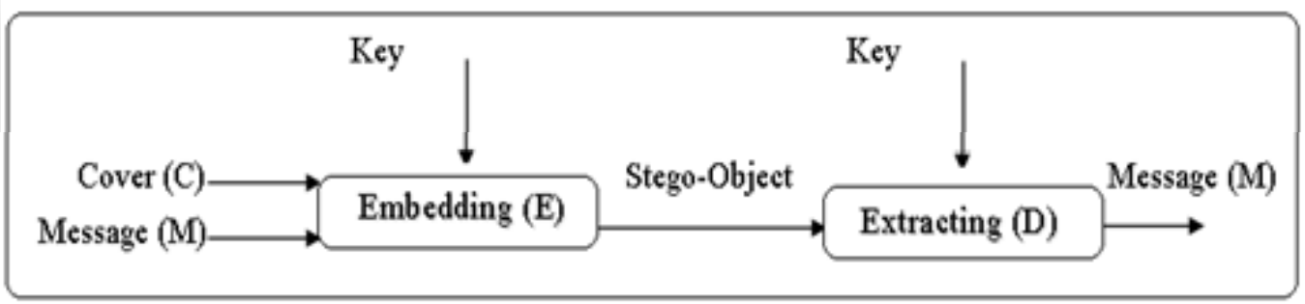*Figure 3.2 Secret Key Steganography [15]*

**3.4 Characterization of Steganography Systems**

Steganographic methods hide a message inside a chosen cover. The weaknesses and strengths of the techniques are characterized by various features. Depending on the application, the importance of each feature is relative. [15][2]

**3.4.1 Capacity**

The capacity refers to the total number of bits concealed and successfully extracted by the Steganographic system.

**3.4.2 Robustness**

The notion of robustness in data hiding indicates the ability of the data to remain intact if the stego-system suffers transformation, such as extra random noise, scaling, loose compression, rotation or linear and non-linear filtering.

**3.4.3 Undetectable**

If the image with the hidden data is consistent with a model of the image source, the concealed algorithm is undetectable. As an example, if a Steganography system embeds the secret messages using the noise component of an image, it should assure it doesn’t make any statistical changes on the noise in the carrier. The format of the cover image’s content and the size of the message to be embedded are directly affecting the detectability of the stego-system.

**3.4.4 Invisibility**

Invisibility or the perceptual transparency is a concept based on the human visual system and audio system’s properties. If an average human cannot naturally distinguish between carriers that contain embedded information and carriers which do not, the hidden information is imperceptible. It is very important that after the embedding, the cover will not be significantly degraded or with a loss of perceptual quality.

**3.4.5 Security**

The notion of security in embedding algorithms indicates that the hidden information discovered by the attacker will not be subject to removal and it depends on the total information about the stego-system and secret key. [15][2]

**3.5 Steganography Techniques**

The Steganographic systems can be categorized according to the cover modifications applied during the embedding process. These methods are grouped in six categories as shown in Figure 3.3.

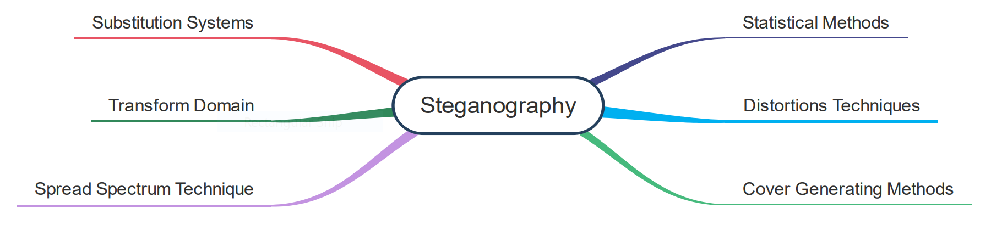

*Figure 3.3 Steganography Classification*

**3.5.1 Substitution Systems**

Substitution Systems consist in encoding the secret information in the insignificant parts of the cover by replacing it with the secret message bits. The information can be extracted only if the receiver knows the positions where the secret information has been hidden. Knowing that in the embedding process only minor modifications are made, the sender can assume that an attacker cannot notice the differences in the cover. [15]

* **Least Significant Bit Substitution**

The least significant bit substitution method consists in choosing a subset of cover elements for the embedding process. These chosen elements will have the least significant bits substituted with bits from the secret message. For the extraction process, these bits will be selected and extracted to reconstruct the secret information.

* **Pseudorandom Permutation**

The pseudorandom permutation method consists in accessing all cover bits in the embedding process in order to distribute the secret message randomly over the whole cover. Since it is not guaranteed that the subsequent bits of the message are embedded in the same order, the complexity for the attacker is increased.

* **Image Downgrading and Cover Channels**

Image downgrading method is a special case of a substitution system consisting in having an image that acts both as a cover and a secret message. It requires a cover image and a secret image of equal dimensions in order for the sender to exchange the four least significant bits from the cover grayscale values with the four most significant bits of the secret image. For extraction, the receiver uses the four least significant bits from the stego-image in order to gain access to the four most significant bits of the secret image. In many cases, the cover degradation is not visually noticeable; therefore it is sufficient to transmit an approximation of the secret image using only four bits.

* **Cover Regions and Parity Bits**

A cover-region is a nonempty subset that can be divided into several disjoint regions that can be used to store the information. One bit of message can be stored in a whole cover-region rather than in a single element.

* **Palette-Based Image**

There are two ways of doing the encoding when using a palette-based image: by manipulating the palette or by manipulating the image data. Just like the substitution method, the least significant bit of the color vectors can be used for transferring the information. Another alternative would be to encode the information in the way the colors are stored in the palette, for the palette does not need to be stored in any way. Knowing that there are N! different ways to sort a palette of N colors, a relative small message can be encoded. A disadvantage of using methods based on the order of a palette to store the message is the lack of robustness, since an attacker could sort the entries in a different way in order to destroy the information.

* **Information Hiding in Binary Image**

In a binary image there are redundancies in distributing black and white pixels. Although there is the possibility of implementing a simple substitution scheme, these systems are not robust enough for there is a high susceptibility to transmit errors.

* **Unused or Reversed Space in Computer Systems**

Unused or reversal space can be taken into advantage for hiding messages without perceptually degrading the carrier. Usually, the operation systems store the files in a way that results in an unused space that is allocated to a file. Knowing that hidden partitions are not seen if the system is started normally, another possibility for hiding information is to create these partitions. [15]

**3.5.2 Transform Domain Techniques**

Substitution and modification techniques are relatively easy ways to embed secret message, but a disadvantage would be the high vulnerability to even small modification. To destroy the secret information, an attacker can simply apply signal processing techniques. A total information loss can occur when there are small changes resulting out of loose compression. Nowadays, most robust Steganographic systems are operating in some sort of transform domain. Transformation domain methods embed the information in a significant area of the cover image that results in a system that is more robust to attacks such as cropping some image processing, compression or adding noise. Although they are more robust to many signals processing, they still remain imperceptible to the human sensory system. A method of transform domain is to use the Discrete Cosine Transformation as a vehicle to hide a message in image. [15]

**3.5.3 Spread Spectrum Techniques**

Spread Spectrum techniques are means of transmission. To send the information there is a use of signal that occupies a bandwidth in excess of the minimum necessary. The band spread is obtained by a code which is independent of the data and the receiver uses a synchronized reception with the code to dispread and to recover the data. Knowing that spread signals are more difficult to remove, the embedding methods that are based on spread spectrum provide a high level of robustness. There are two special variants of spread spectrum techniques for information hiding: direct sequence and frequency-hopping scheme. For direct-sequence technique the secret signal is spread by a constant called ship rate and modulated with a pseudorandom signal and then added to the cover. For frequency-hopping schemes the frequency of the carrier signal is modified such that it hops quickly from one frequency to another. [15]

**3.5.4 Distortion Techniques**

The distortion technique requires knowledge of the original cover for the decoding process. In order to obtain a stego-system, the sender applies to the cover a sequence of modifications chosen in such a way that it corresponds to a secret information to be transmitted. The receiver measures the difference in the original cover for reconstructing the sequence of modification that have been applied by the sender in order to rebuild the message. One of the first approaches for hiding information is in text. Text-based hiding methods are mainly of distortion type. This means that the arrangement of words or layout of a document can reveal information. One technique would be to alter the positions of line and words. Another technique would be to add “invisible” characters to the text such as spaces, tabs and line breaks. This method works best when using HTML files because web browsers ignore extra spaces and lines so these can go unnoticed until the source of the web page is accessed. [15]

**3.5.5 Cover Generation Techniques**

Some Steganographic applications generate a digital object when embedding secret information to a specific cover. This is created only for the purpose of being a cover for the secret communication. An example can be automated generation of English text. A large dictionary of words categorized by different types can be used together with a style source which describes how words of different types can be used to form a meaningful sentence. To transform the message bits into sentences the words need to be selected according to the given style source. [15]

**3.5.6 Statistical Steganography**

Statistical Steganography method utilizes the technique of embedding one bit of information in a digital carrier. This is done by altering the cover in such a manner that some statistical characteristics change in a significant way if a ‘1’is transmitted. Otherwise, the cover is unchanged. In this way, the receiver can distinguish unmodified covers from modified ones. [15]

**3.6 Image Steganography**

In Image Steganography, secret information is protected by embedding them in an ordinary image, called cover image, to create a stego image. If the image can be restored after the secret data has been extracted it means that a reversible process has been used. These processes are usually used for military and medical images. Otherwise, the process is irreversible. The assumption of data hiding is that all of the data embedding operations on cover images are imperceptible. This means that when a stego image is being delivered to the receiver, an illegal observe should not be able to perceive any distortion. In addition to this, the secret data should not be modified by any means. If the embedding methods are used inappropriately such that some statistics of cover images are changed, some abnormal phenomena can occur. Although this may not be detected with the naked eye, it can be often detected by using appropriate statistical testing and analysis, known as steganalysis. [14]

The methods for measuring the performance of data hiding can be classified into three types: the compressed domain, the frequency domain and special domain, the most popular criteria being PSNR and embedding capacity. PSNR (peak signal to noise ratio) measures the difference between the stego image and cover image. The PSNR of a hiding method is high if it can maintain a quality stego image with low distortion, which is visually identical to the cover image. The embedding capacity is defined by the maximum number of bits of secret data that can be embedded per pixel (bpp) in a cover image. The higher the bpp, the better the process is.[14]

**3.6.1 Prior Work**

Adelson describes a method of data embedding that exploits the varying sensitivity of human visual system to contrast spatial frequency. The method consists in substituting high-spatial frequency image data with hidden data in a pyramid-encoded still image. Although the method can encode a large amount of data efficiently, there is no provider to make the data immune to detection or removal by typical manipulation such as rescaling and filtering. Bender modifies Adelson’s technique for encrypting the embedded data by using chaos. His proposed concept uses a LSB scheme that encodes data only in the least-significant bit of the cover image. This technique has the same problems as Adelson’s method, but it adds an additional one, which is the degradation of the image. Although it has these disadvantages, this method is used extensively due to its high embedding capacity and its low computational complexity. Chen introduced a data hiding method with high payload that uses the LSB scheme together with hybrid edge detection steganography mechanism. The hybrid edge detector was constructed using a fuzzy edge detector and the Canny edge detector which resulted in achieving both high embedding capacity and high quality of the stego image through our human visual system. Wang proposed a generic algorithm that generates a substitution table to improve the quality of the stego image. In order to improve Wang’s method, Chang proposed a dynamic programming method that efficiently picks out the best substitution table in order to achieve a better performance. Wang used the modulus value as a threshold value for deciding the number of bits of the secret data that can be incorporated into the cover image in order to obtain a higher embedding capacity. Other techniques, such as Hecht’s Data-Glyph that consists in adding a bar code to images, are engineered in light of a predetermined set of geometric modifications. [13]

**3.6.2 Problem Space**

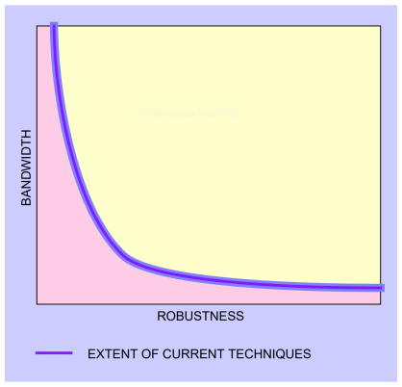Data hiding requires a different embedded data rate and different level of resistance to modification that form the theoretical data-hiding problem space as described in Figure 3.4. There is a trade-off between bandwidth and the degree to which the data are immune to attack or transformations that appear to the host signal through normal usages, such as resampling, compression. Therefore, the encoding is less secure when there is more data to be hidden and the encoding is more secure when there is less data to be hidden. [14]

*Figure 3.4 Data Hiding Problem Space [13]*

**3.6.3 Data hiding in still images**

There is a variety of challenges that arise for data hiding in still images. The main reason for these is the way the human visual system works and the typical modifications that are made on images. Furthermore, still images provide a relatively small host signal for hiding data. A typical 8-bit picture of 200 x 200 pixels can provide approximately 40 kilobytes of data space in which the data can be embedded. In addition to this, still images can be expected to be subject to operations ranging from simple affine transforms to nonlinear transforms, such as lossy compression, blurring, filtering and cropping. A data-hiding technique is practical if it can be resistant to as many of these transformations as possible. [14]

Although these challenges occur, still images are reasonable candidates for data hiding. There are many attributes of the human visual system that can be exploited in a data-hiding system. This includes the varying sensitivity to contrast as a function of the masking effect of edges and spatial frequency. The human visual system has a low sensitivity to small changes in luminance. It is able to perceive changes of no less than 1/30 for random patterns. However, the human visual system is more sensitive to change of the luminance in uniform regions of an image, approximately 1/240. Another vulnerability of the human visual system is the relative insensitivity to very low spatial frequencies such as continuous changes in brightness across an image. Furthermore, an advantage when working with still images is that they are no causal. This means that data-hiding techniques can have access to any block of pixels or pixel at random. Using all of these observations, there was a variety of techniques developed for placing data in still images. Some techniques are more suitable when dealing with small amounts of data, while others when dealing with large amounts. Some are highly resistant to geometric modifications, while others are more resistant to non-geometric modifications, such as filtering. [14]

**3.6.4 Low bit rate data hiding**

A low bit-rate encoding expects a high level of robustness in return for a low bandwidth. The important part is the resistance to attempts of data removal by a third party.

* **Patchwork: A statistical approach**

The statistical approach, which is referred as Patchwork, is based on a pseudorandom, statistical process. Patchwork invisibly hides in a host image a specific statistic that has a Gaussian distribution. Two patches, A and B are pseudo randomly chosen. The image data in patch A is lightened and the data in patch B is darkened. In Figure 3.5 this is exaggerated for the purposes of the illustration. This unique statistic indicates the absence or presence of a signature. This method is independent of the contents of the host image and it shows fairly high resistance to most no geometric image modifications. [13]

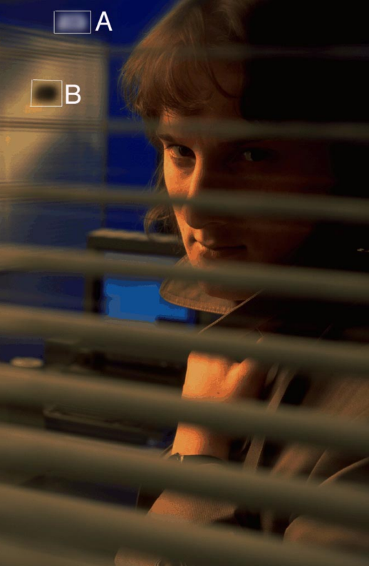

*Figure 3.5 Application of Patchwork [13]*

* **Texture Block Coding: A visual approach**

Another method for low bit-rate data hiding in images is Texture Block Coding. This method embeds data within the continuous random texture patterns of an image. The implementation of this technique consists in copying a region from random pattern of texture found in an image to an area that has similar texture. This results in a pair of identical textured regions in the picture as shown in Figure 3.6 and Figure 3.7.

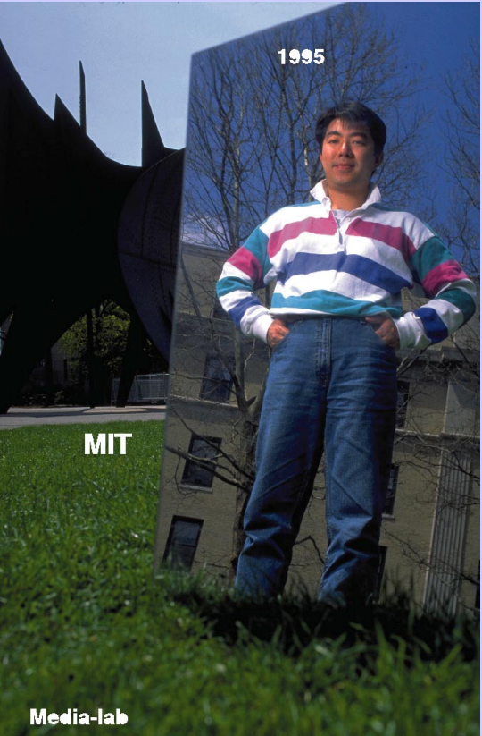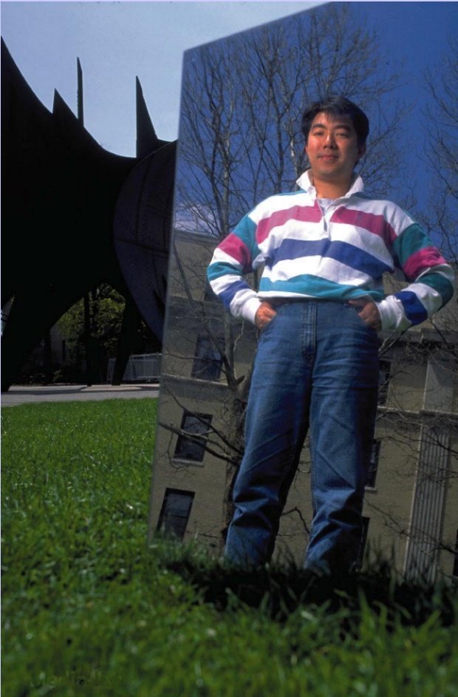

*Figure 3.6 Texture Block Coding Example [13]*

*Figure 3.7 Texture Block Coding Example [13]*

If the picture is uniformly transformed, the two regions are modified in the same way because they are identical. If the regions are reasonably large, the inner part of the block changes fairly under most non-geometric transformations. Texture Block Coding also has its disadvantages: it requires a human operator to choose the source and destination regions and also to evaluate the visual impact resulted from the modifications made on the image. This process could be automated by allowing a computer to identify possible texture regions that can be used to copy from and paste to. Nonetheless, this technique might not work on images that lack areas of continuous texture that can be used to draw. [13]

**3.6.5 High bit rate coding**

High bit-rate techniques can be intended to minimize the effect on host signal perception, but they do not tend to be immune to image changes, but there is in assumption that a relatively large amount of data can be encoded. The most common high bit-rate encoding technique is the one that uses the replacement of the least significant luminance bit of the cover image with the embedded data. Other techniques include the use of direct sequence spread spectrum coding, the introduction of high-frequency, low-amplitude noise. The use of error-correction coding can make the high bit-rate methods more robust, at the expense of data rate. High bit-rate codes are appropriate when there is a reasonable expectation that a great deal of control will be maintained over the pictures

Individually, none of the known methods for data embedding are resistant to all possible transforms or combinations of these. Usually, one technique can supplement another one if combined. Supplementary techniques are especially important for recovery from geometric modifications such as maintaining synchronization for spread-spectrum encoding and affine transformations. [13]

**3.6.6 Applications**

Embedding data in images is of great advantage in many applications. In the following section there will be presented applications that differ in the quantity of data to be hidden and the type of transforms to which the data are expected to be subjected. [14]

* **Digital watermark**

The main goal of a digital watermark is to place a permanent mark on an image. Frequently, this means a handful of bits to be encoded, sometimes just a few, or only one. This stamp can be used for tracing the distribution of images for online news services and for photographers who sell their work for digital publications. There could be a digital camera that places a watermark on every picture the camera takes. Suppositional, this would allow photographers to locate sites where their photographs are used by employing a web-searching agent.

It can be anticipated that if an image has information about legal ownership hidden in it, someone might want to remove it. Therefore, a digital watermark is required to me difficult to be removed. [14]

* **Tamper-proofing**

The objective of tamper-proofing is to determine if an image has been modified. Although most data-hiding techniques attempt to secure data in the face of all modifications, tamper-proofing techniques must be resilient to small modifications, but not too large modifications. Therefore they must be resilient to cropping, tone-scale or gamma correction for images or balance or equalization for sounds, but not for removing or inserting people from an image.

There are several ways to implement tamper-proofing, the easiest one being encoding a check-sum of the image within the image. Yet, this method is triggered by small modifications in the picture, which suggests an approach involving a pattern overlaid on the picture. To have a successful overlay, one must find a pattern resilient to simple modifications such as gamma correction and filtering, but not easily removed. [14]

* **Feature tagging**

Tagging the location of features within an image is another application of data hiding. One might want to have an editor that can encode descriptive information, such as the location and identification of features of interest, directly into specific regions of a picture, which can be possible using data hiding. This allows the descriptive data to be retrieved wherever the image goes. The embedded information is spatially located in the image. Therefore, this is removed only if the feature of interest is removed and it can be scaled, translated and rotated exactly as the feature of interest is.

This application does not require the same robustness as the digital watermark does. Knowing that feature location is providing a service, it can be assumed that it is not likely for someone to maliciously try to remove the encoded information. [14]

* **Embedded captions**

Knowing that typical news photograph captions contain 1 kilobyte of data, it can be said that embedded captions is a relatively high bit-rate application for data hiding. Similarly to feature tagging, caption data are usually not a subject to malicious removal. Even if captions are useful by themselves, they can become even more useful if combined with feature location, by creating portions of the caption that directly reference items in the image. The reference to an item referenced in the caption can be automatically removed if that item is cropped out of the picture. [14]

**4. Architecture and Implementation**

**4.1 Overview**

The purpose of the following chapter is to present the architecture and implementation of the application. Cryptonos is a two layered application that allows the user to securely store information in images. This is done by encrypting and hiding the message in the pixels of the image. Furthermore, the application gives the user the possibility to extract and decrypt messages from images. By combining cryptography with steganography, the security of the data is considerably increased. But there is never enough security, or security itself. One method can be considered secure until one can break it and make it vulnerable. The purpose of this application is to increase the security one can have for its data. Therefore, it allows you to choose the bits that you want the algorithm to use when hiding your message. Knowing that the user can choose from 8 bits, we can say that there is actually an 8-bit key used. Therefore, this technique will use 2 secret keys for hiding and encrypting and for extracting and decrypting.

The application comes with a very user friendly interface that can be used by both users who want a default solution and users who want to customize the embedding process. The design of the application does not use any templates, but only originals ideas. Also the used default pictures are entirely taken by the author of this paper. Furthermore, the logo has been created especially for the purpose of being in this application.  Therefore, we can say that Cryptonos is 100% original when it comes to the user interface.

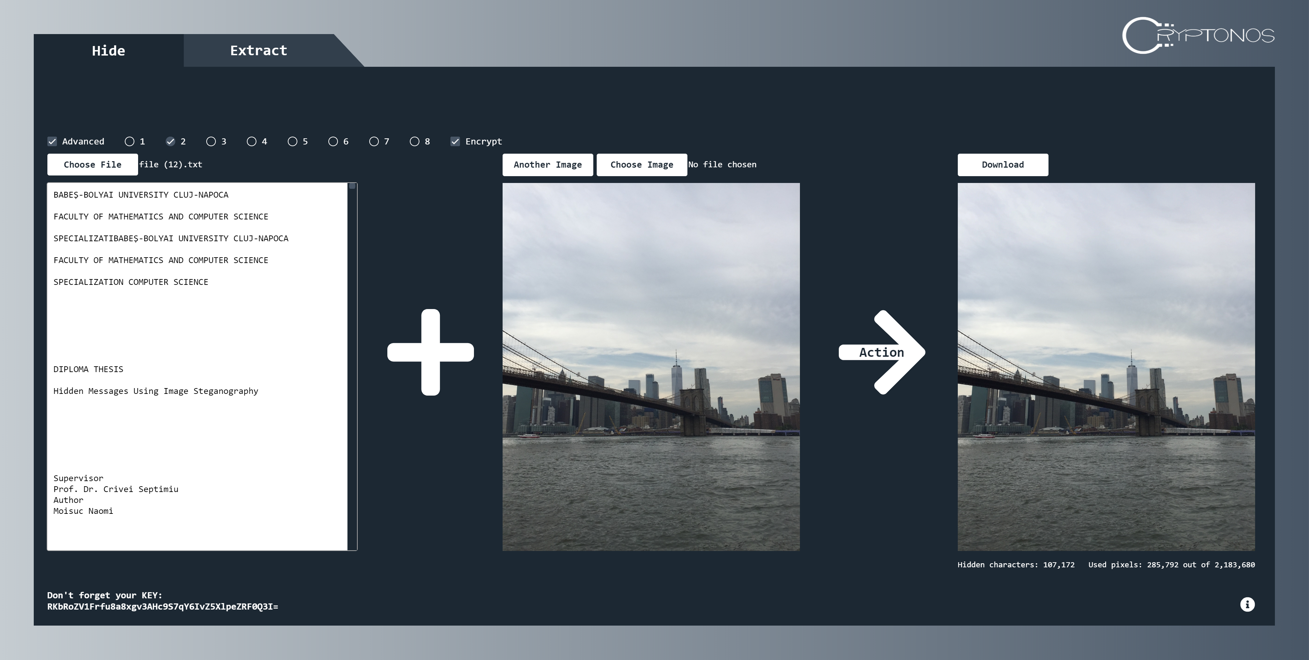

*Figure 4.1 Hiding the Message*

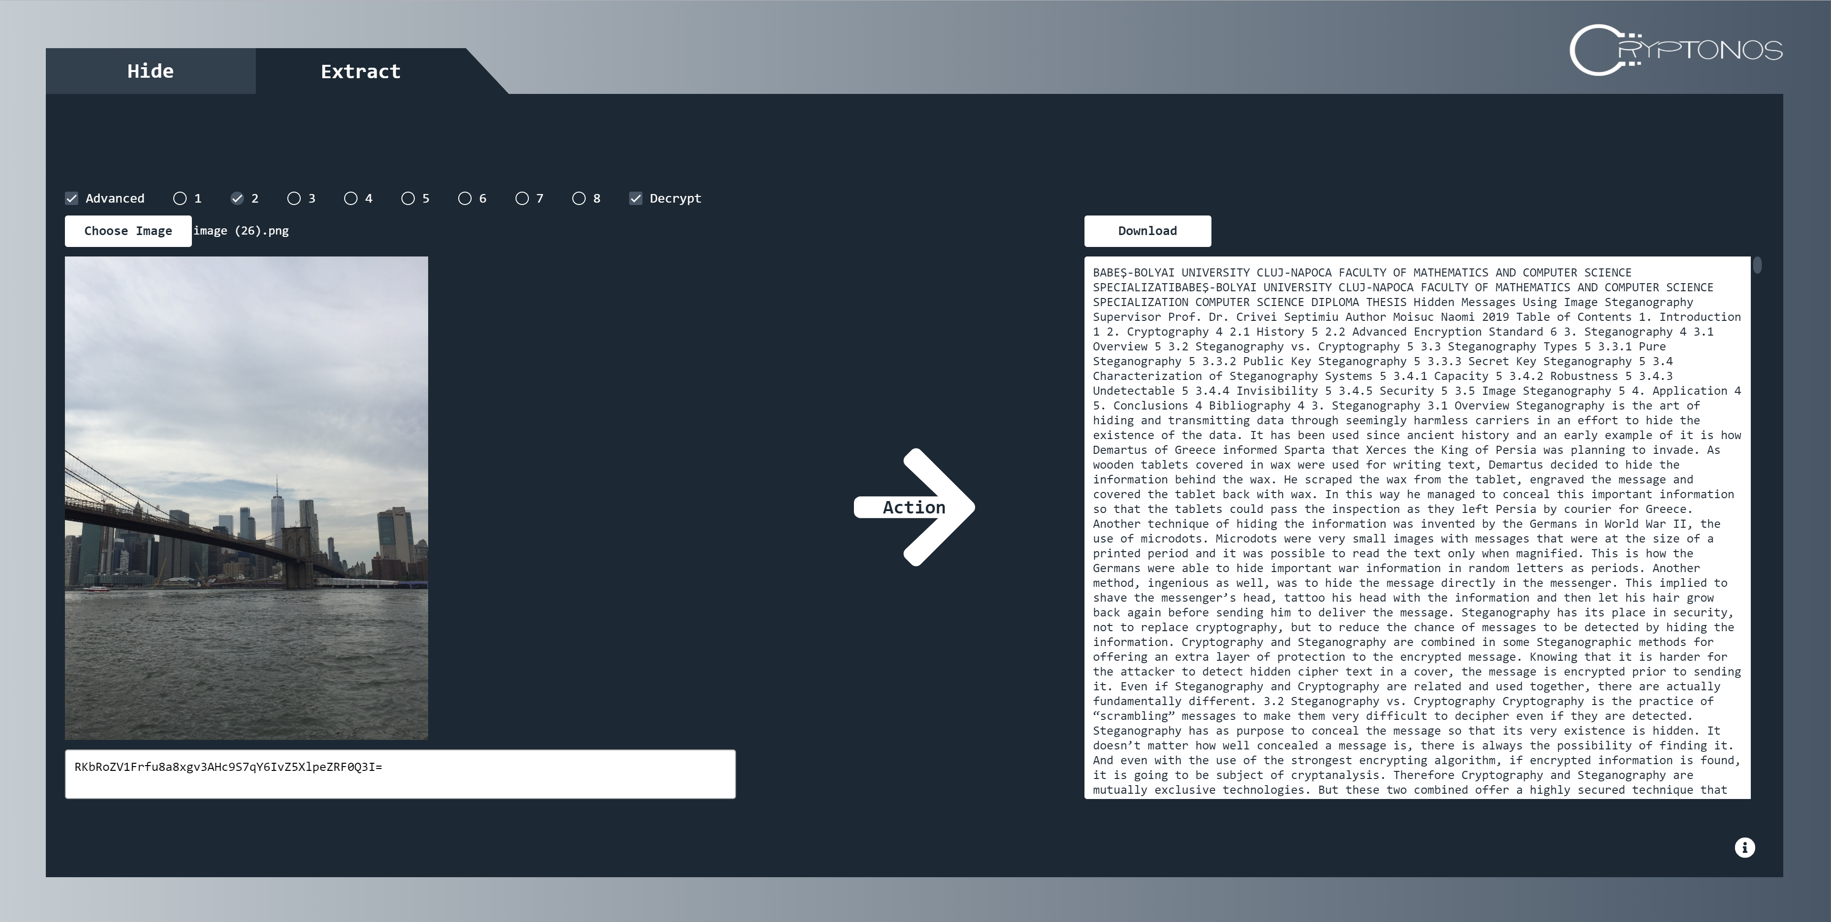

*Figure 4.2 Extracting the Message*

**4.2 Technologies**

As mentioned in the previous paragraph, the application is based on two layers: client side and server side. The server side is implemented in .NET while the client side in Angular.

* **.NET**

.NET is an open source developer platform for building different types of applications such as web, mobile, desktop applications and other. It is a free, cross-platform created by Microsoft and it can use multiple languages, editors and libraries. .NET applications can be written in C#, F# or Visual Basic. [1]



*Figure 4.3 .NET Advantages*

* **Angular**

Angular is a framework and platform for building applications in HTML and TypeScript. It is written in TypeScript and it implements core and optional functionalities. These are built as a set of TypeScript libraries that can be imported into the apps. Its library offers features that make the implementation of complex requirements of modern apps very easy. Angular allows the developers to achieve powerful results with a small amount of code. [6][11]

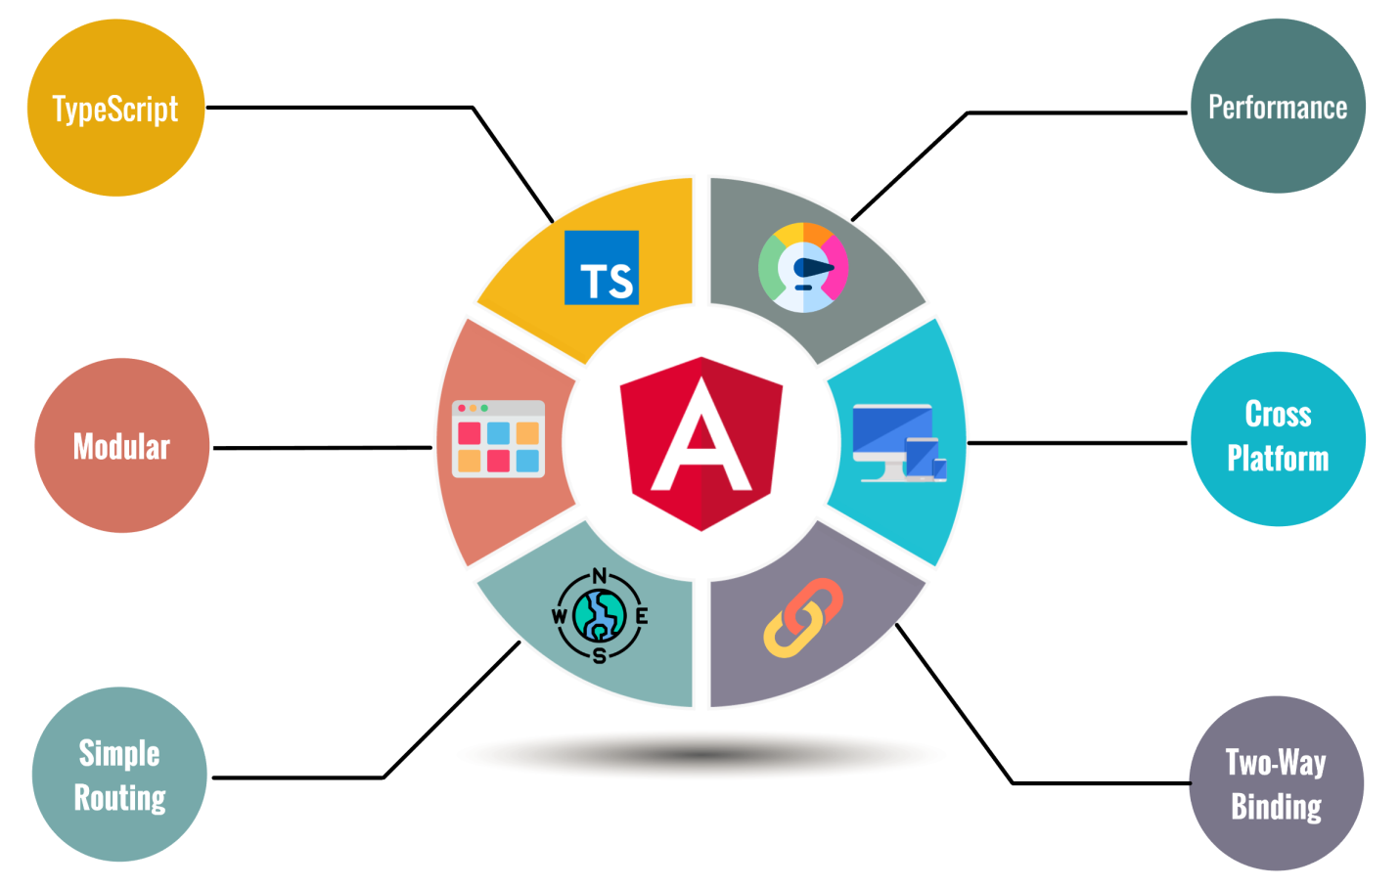

*Figure 4.4 Angular Advantages*

**4.3 Use Cases**

This one-page application is very straightforward and it mainly contains two tabs: one for the hiding part and one for the extracting part. If the user does not know how to use it, there is an Info Point for each part to describe how to hide and extract the desired message.

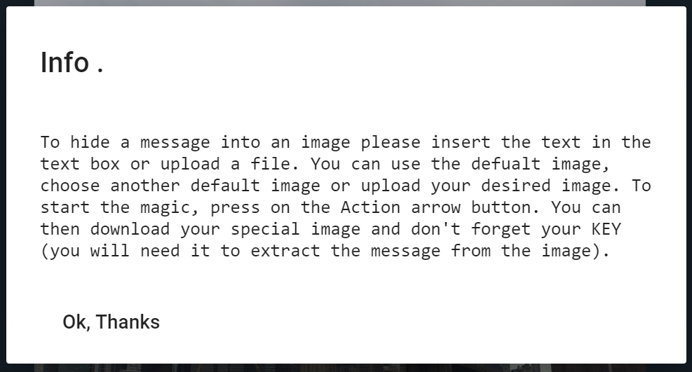

*Figure 4.5 Info Point for Hiding*

In the Figure 4.6 it can be seen an overview of the two use cases that can be performed by the application.

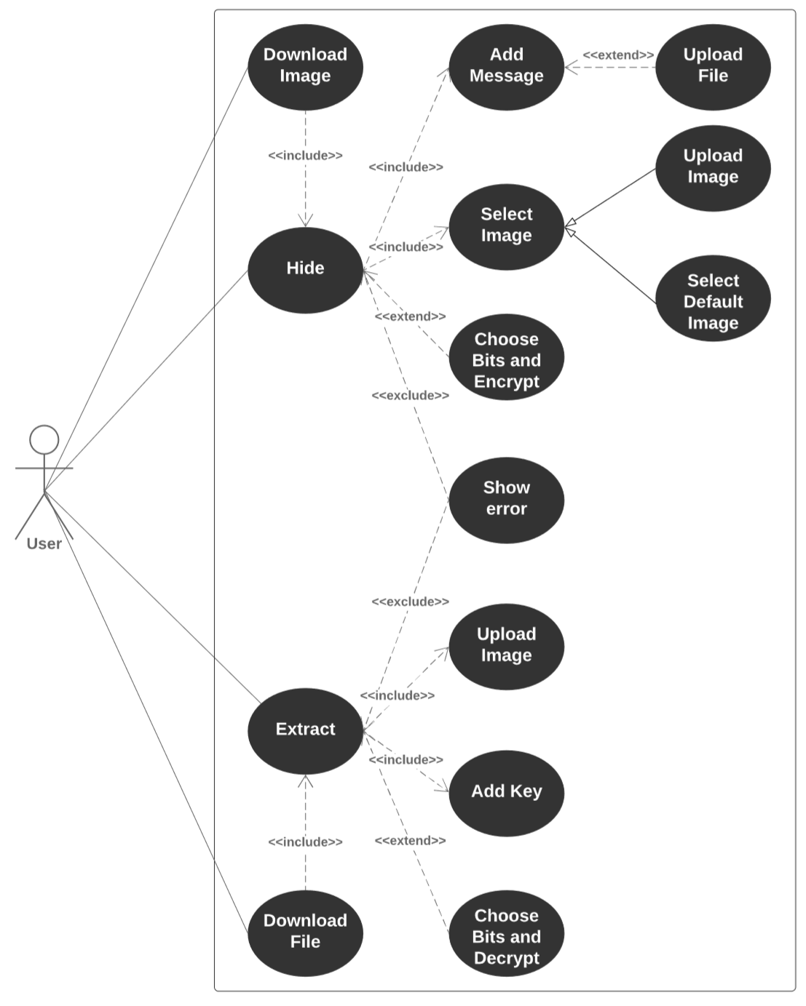

*Figure 4.6 Use Case Diagram*

In the case of hiding the message, the user can choose to either type in a message or to upload a text file (.txt). This text file will automatically populate the input area. When it comes to choosing the image that will contain the hidden data, the user can either choose from a set of random default pictures, or import an image of its choice, of type .jpg, .jpeg, .png and other. The message and the image are the only required elements for proceeding with the embedding process. The user can choose to hit the *Action* button and get the desired result, or it can choose to customize the embedding process by selecting the bits on which the data will be hidden. This belongs to the *Advance* part. In this section, the user can also choose if it wishes the message to be encrypted or not. For better security, the recommendation would be for the encryption to be selected. But this feature can help proving some concepts regarding the combination of cryptography and steganography, but this will be discussed in the next chapter. After choosing all these, the program will give the final result which consists in an image that has the embedded information and the encryption key that will be used for decrypting. In addition to this, it will give some statistics regarding how many characters have been hidden, how many pixels have been used for this process and how many pixels are there in total. This will help showing the difference between hiding the data only on 1 bit and hiding it on 5 bits; less pixels will be used for the second one. The image can be and it is recommended to be downloaded so that it can be sent or stored and then it can be used for extracting the secret message.

In the case of extracting the secret message, the user must choose an image that might or might not have a hidden message and add the decryption key. By hitting the *Action* button, a message will be extracted and decrypted and displayed on the screen. This message can be downloaded in a text file. However, this process might seem to not work properly sometimes. But this would be because either the decryption key is not correct, or the selected bits are not the same as the ones that have been selected when embedding the data. At this point, the user also has the possibility to choose whether it wants the message to be decrypted or not.

For both cases, if any type of error occurs, there will be an error message displayed.

**4.4 Event Scenarios**

Now that we know what the application can do, let us see how it does it. Figure 4.7 shows the more in detailed flow of the hiding process.

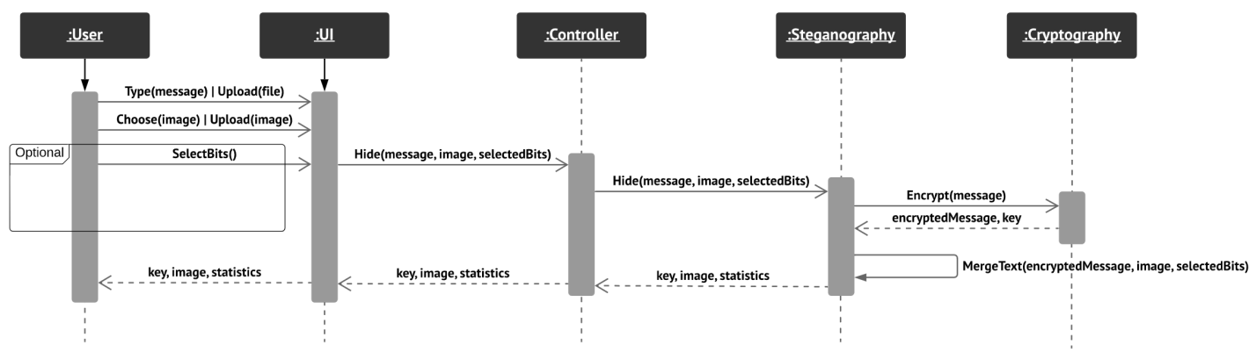

*Figure 4.7 Sequence Diagram - Hide*

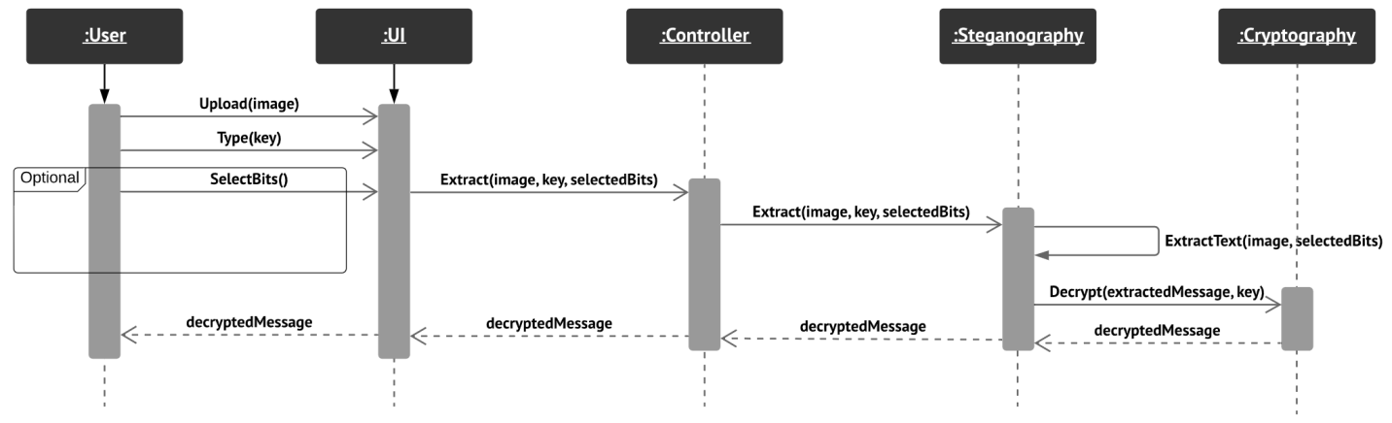For the encryption sequence, the user introduces a message or uploads a file with a message and chooses an image or uploads an image. It can also choose the custom bits and whether or not to encrypt the message. All these are happening on the client side, between the user and the UI. After the *Action* button has been clicked, the UI sends the parameters to the Controller. At this point, the Controller sends the message and the image, together with the selected bits and whether the encryption is desired or not, to the Steganography module. From here, if the message is desired to be encrypted, the message will be sent to the Cryptography method. This one will return the encrypted text, together with the encryption key.  The resulted message is then embedded in the image based on the selected bits. This is done at the Steganography module level. The final image, together with the encryption key and statistics, are sent back to the UI so everything can be displayed in order to let the user collect the final results.

*Figure 4.8 Sequence Diagram - Extract*

For the decryption sequence, the user uploads an image and types in a key. It can also select bits of its choice and whether or not the text should be decrypted. All these are sent by the UI to the Controller, which will send everything to the Steganography module. At this level, the message will be extracted based on the selected bits. If the decryption is desired, the message will be sent to the Cryptography module together with the decryption key. The final result it is sent back to the UI level so it can be displayed and let the user see it and download it.

**4.5 Server Side**

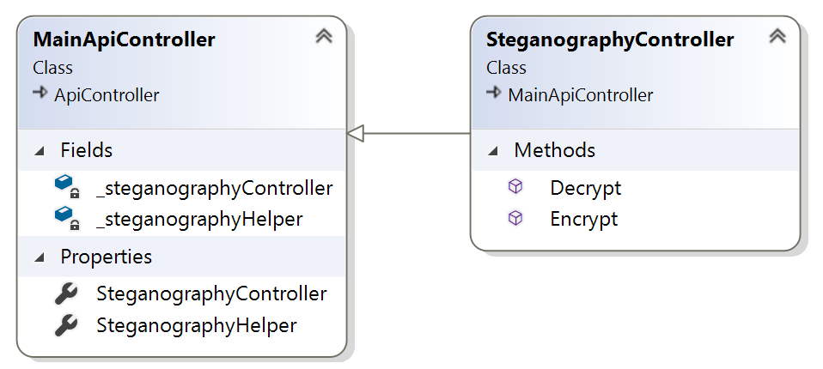The server side of the application is built on two layers: Web API and Business Layer. The Web API Layer establishes the connection with the UI via REST web services, while the Business Layer contains the core functionalities of the application. A modular architecture separates each layer in different projects. This is useful if the application must be extended and it diminishes the risks when changes need to be made.

*Figure 4.9 Class Diagram – Web API*

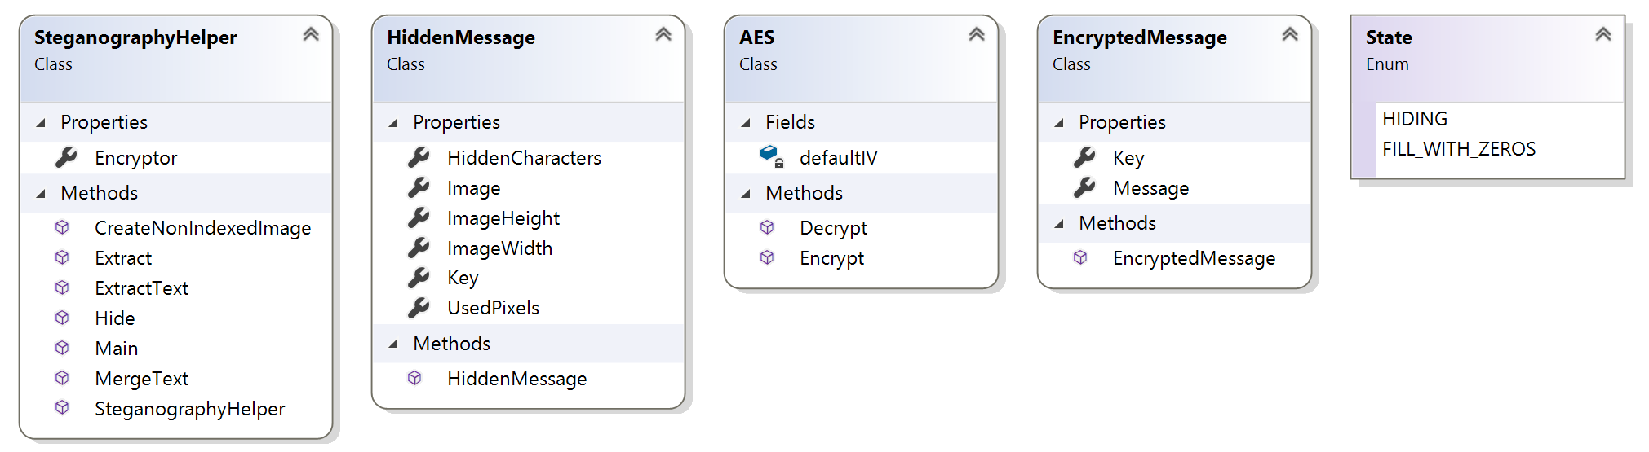

*Figure 4.10 Class Diagram – Business*

Going further with the explanation, we can discuss in depth the steganographic and cryptographic parts of the application.

**4.5.1 Implementation of Steganography**

One of the standard implementation for steganographic methods is based on replacing the least significant bits with the bits of the message to be embedded. However, this application implements a method that uses specific bits for hiding the message. This feature can improve the security of the data.

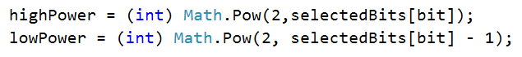The algorithm uses a Bitmap represented in RGBA model on 8 bits. It parses each pixel starting from the first row, first column, until the whole message is being hidden. For each pixel, the array that contains the chosen bits is being parsed. Based on the current bit rank, a highPower and a lowPower will be computed as power of 2.

*Figure 4.11 Power of 2 based on current rank*

These will be used for doing all the computations. It could be said that this is the key of the algorithm, the main piece that makes it generic. Taking the current pixel, the current bit rank will be set to 0:

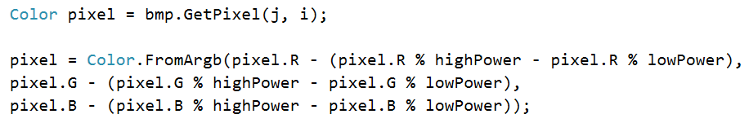

*Figure 4.12 Set the current bit rank to 0*

This is followed by other 3 steps, for each R, G and B. If at this point the colorUnitIndex has reached a number multiple of 8, it means that a full character has been embedded. If the last character was 0, it means that the process has come to its end. If the last character embedded was the last character of the message, then there will be 8 bits of 0 embedded so it will mark the end of the message. And if none of these apply, then the next character of the message will be selected in order to hide it.

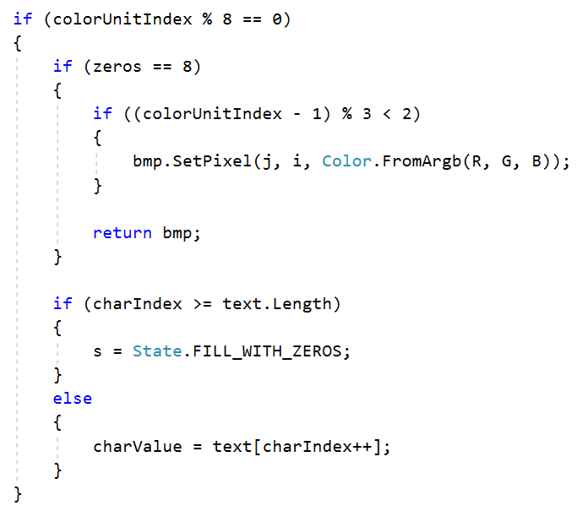

*Figure 4.13 A full character has been embedded*

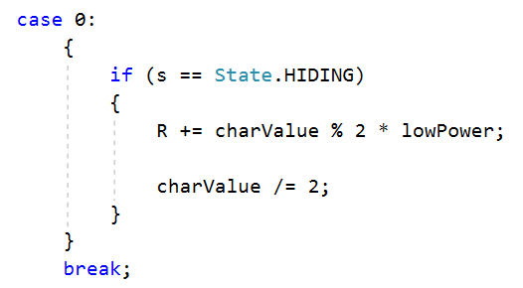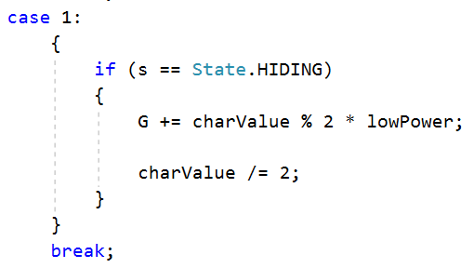For each R, G and B, the bit from the current bit rank will be replaced with the current bit from the current character as it follows:

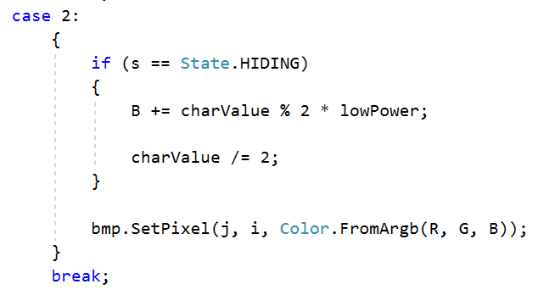

*Figure 4.14 Add the Current Bit in the Current Pixel*

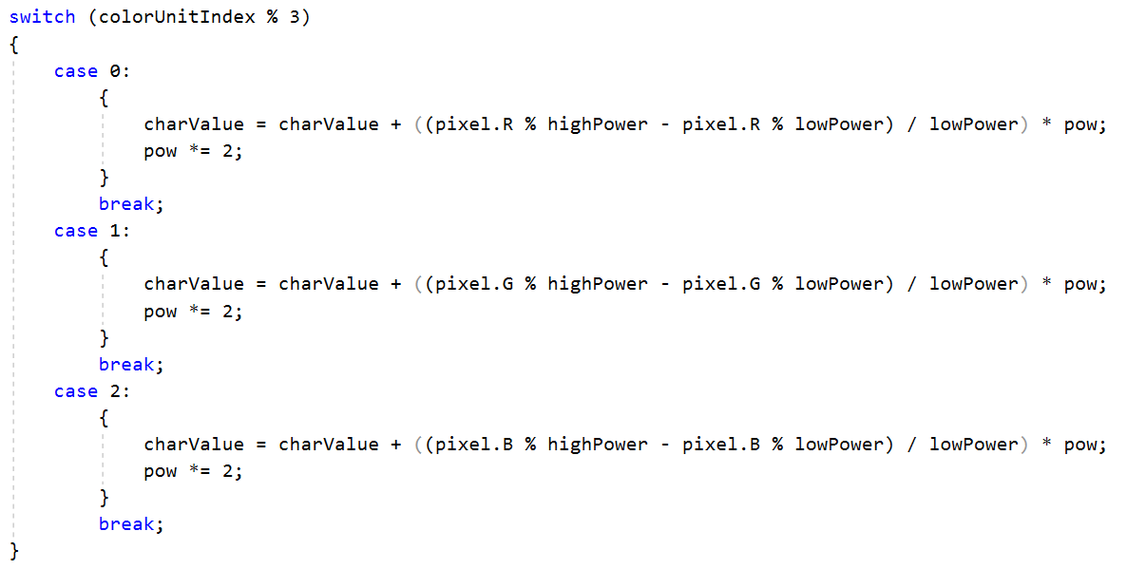For extracting the message, the algorithm is similar to the one used for hiding it, but reversed. Therefore, to take the bit from the current bit rank of each R, G and B, the following computations will take place:

*Figure 4.15 Extract the Bits from the Current Pixel*

**4.5.2 Implementation of Cryptography**

The encryption and decryption of the message plays an important role in this application. Therefore, it has been used a high level implementation of AES provided by .NET for the cryptographic part. For both processes there are two “keys” used: the secret key and the initialization vector. However, in this application, the initialization vector is a default value stored locally, to simplify the user experience. In the encryption part, a new secret key is randomly generated, while for the decryption part, the secret key is provided.

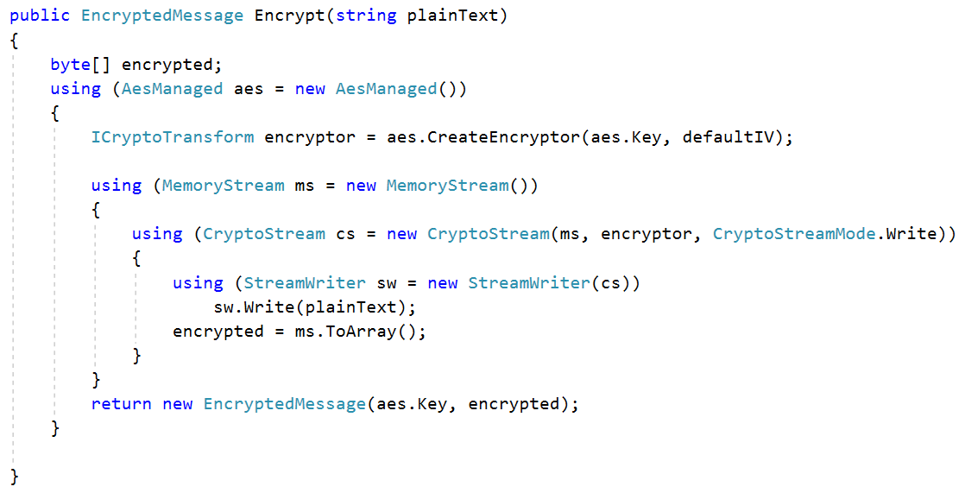

*Figure 4.16 AES - Encrypt*

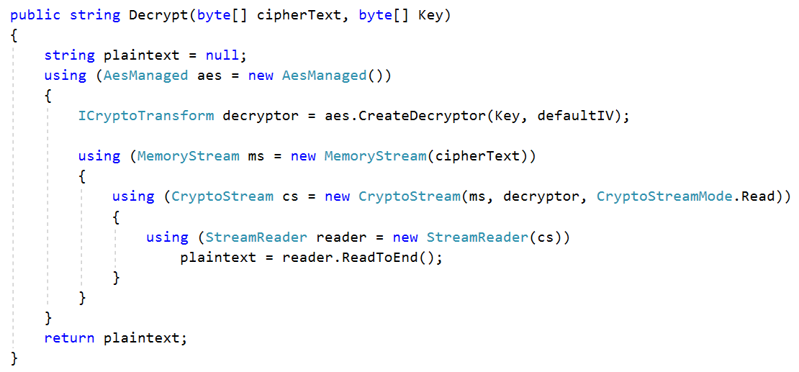

*Figure 4.17 AES - Decrypt*

**4.6 Client Side**

The client side of the application is implemented using Angular framework. This user interface is the one that connects the user with the application itself. The architecture of the client side is based on components. Every piece that has a single functionality is in separate component. Angular makes the encapsulation of a component and the communication between the very easy to use. Each component has its own html, scss and typescript file. Thus, everything is in one folder and these are using each other without any specific implementation.

The connection with the API is established using HTTP Client class. A single service has been created for this purpose and injected to each component that uses the API. For handling errors, an Error Interceptor has been created. In this way, the errors are being caught and handled whenever they occur. Whenever an API call is performed, a loader is being displayed to let the user know what is happening. But having an interceptor for the errors, the loader couldn’t be stopped, because it belonged to a specific component that the interceptor didn’t have access to. Therefore, an injectable HTTP Status Class has been implemented in order to have access to the status of the application at any time. This has been injected together with the service in order to be used.

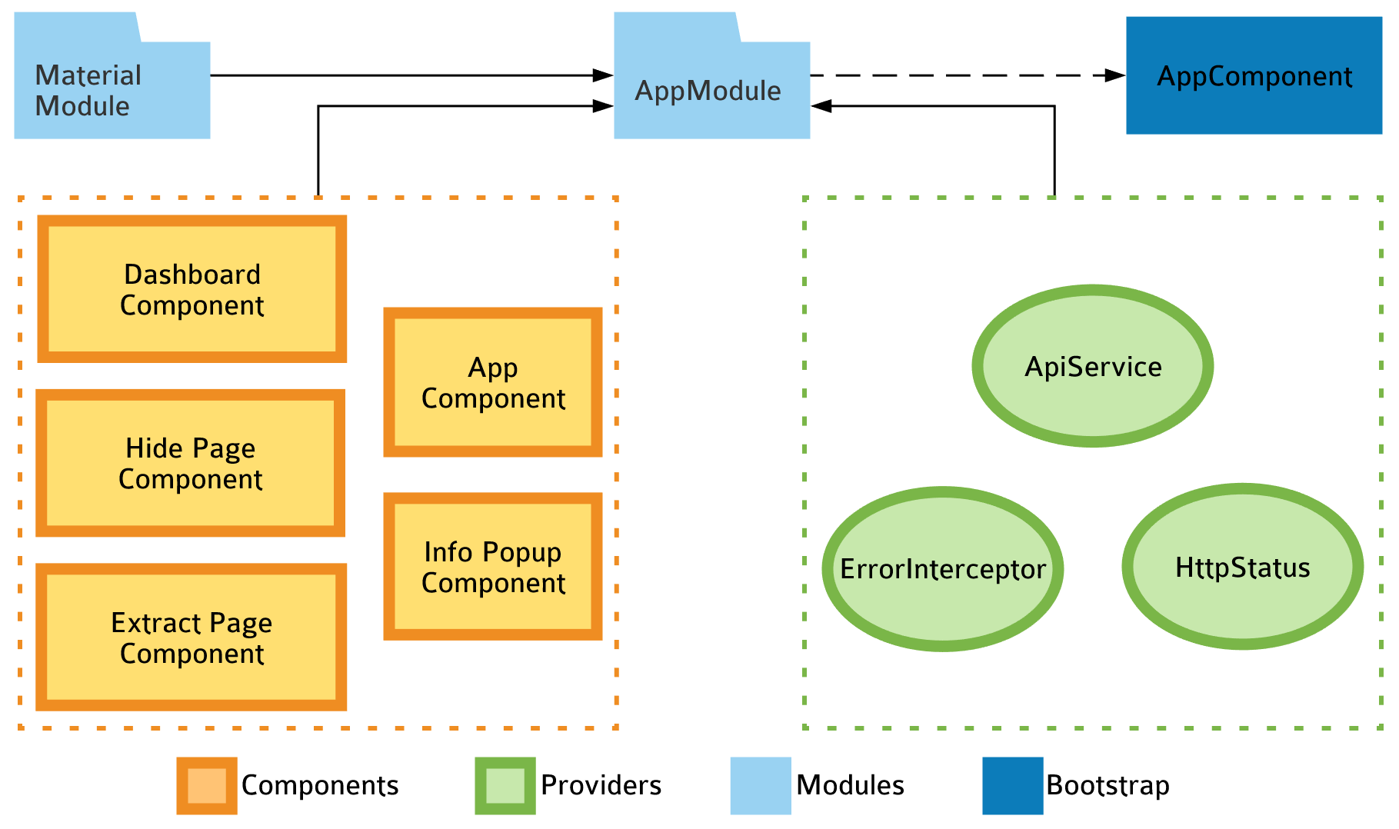

*Figure 4.18 Module Diagram*

**5. Results**

The purpose of this chapter is to present in detail how using Cryptonos can secure the data, how it impacts the images and how noticeable the changes made on the images are for the naked eye. Furthermore, it will be discussed the importance of the keys used by the algorithm.

**5.1 Hide**

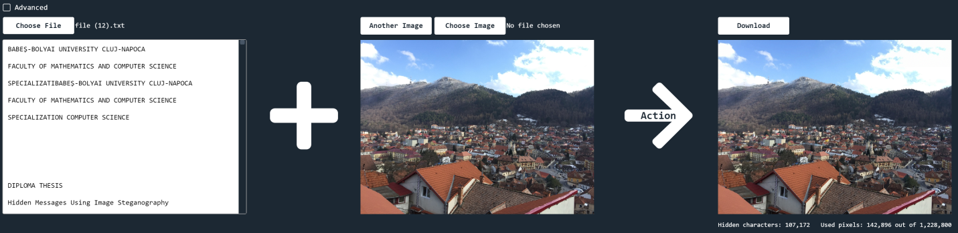The default settings use the 1st and 2nd bits for hiding the information and it also encrypts it. The changes made on the image are not visible; therefore it can pass as an ordinary image.

*Figure 5.1 Hide – Default settings (1st and 2nd bits + encrypt)*

Advanced settings allow the user to choose the bits that will be used for hiding. It can be seen that when the data is embedded on the 3rd bit, the changes on the image are starting to be visible:

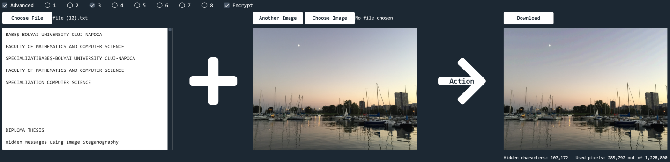

*Figure 5.2 Embedding on the 3rd Bit - Noticeable*

But these changes are not seen on every image; it also depends on the colors of the image if the modifications can be noticed with the naked eye or not. A large area that has the same colors, when altered, it is noticed. But an area that combines more colors, especially darker ones, it passes unnoticed when altered.

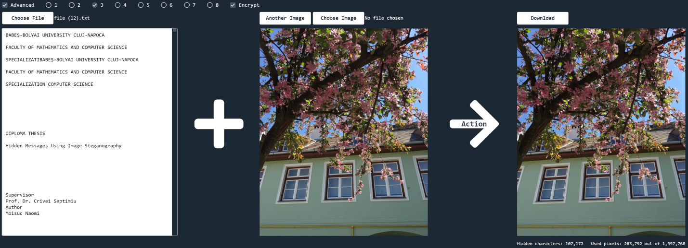

*Figure 5.3 Embedding on the 3rd Bit - Unnoticeable*

Starting with the 5th bit, there is a very low possibility to not notice the changes. And as it can be seen in Figure 5.4, it also depends whether the colors are light or dark. In this example, the leaves seem untouched, but the sky is obviously changed.

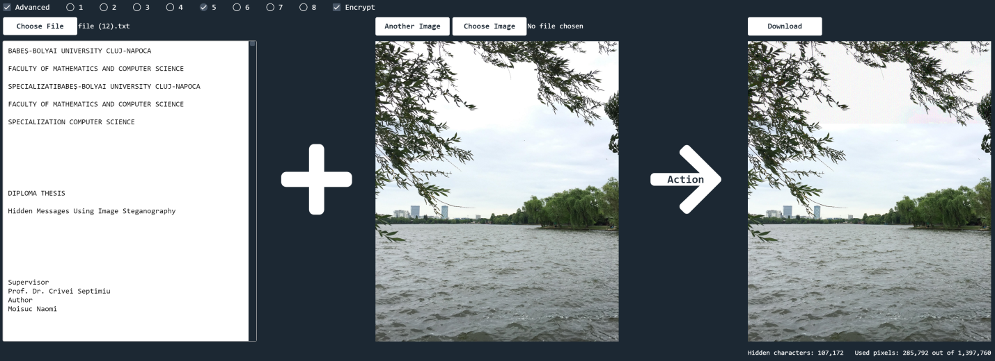

*Figure 5.4 Embedding on the 5th Bit*

An advantage when choosing to custom the hiding process is that more data can fit in the image. The more bits are used, the more data can be embedded. When trying to hide more characters than can be fit, an error message is displayed. This is given at the backend layer by using the following computation:



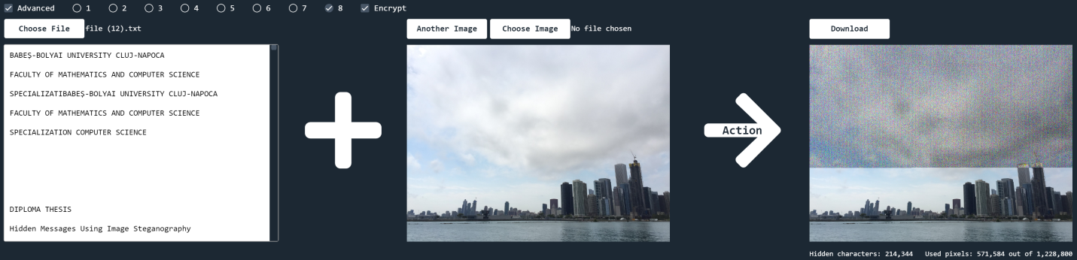

*Figure 5.5 Check if the Data Fits in the Image*

*Figure 5.6 Only 1 bit used*

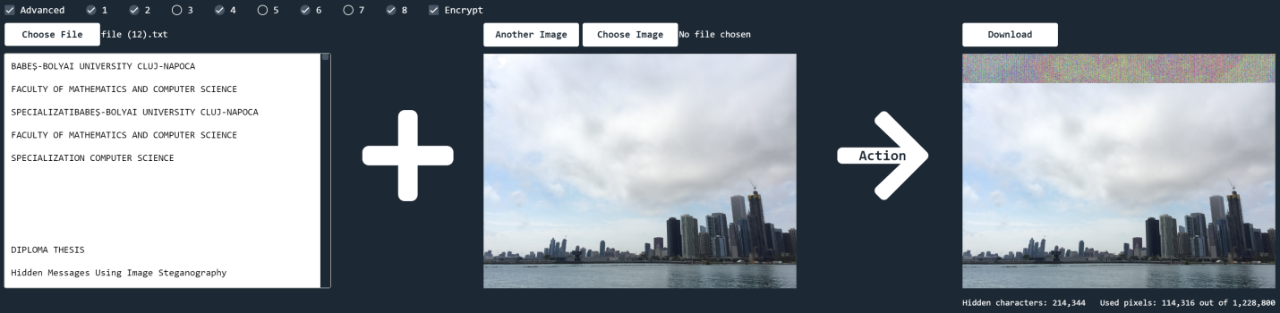In Figure 5.6 it can be seen that only 1 bit has been used. Therefore, 571.584 pixels have been used to hide the information. But this number would decrease considerably if there would be 5 bits chosen; in this case, only 114.316 pixels will be used.

*Figure 5.7 Use 5 Bits for Embedding*

**5.2 Extract**

In Figure 5.8 is demonstrated the importance of well-chosen bits to be used. Knowing that there are 8 bits, we can say that this is a key. If this key is not given correctly, the embedded message will not be extracted properly.

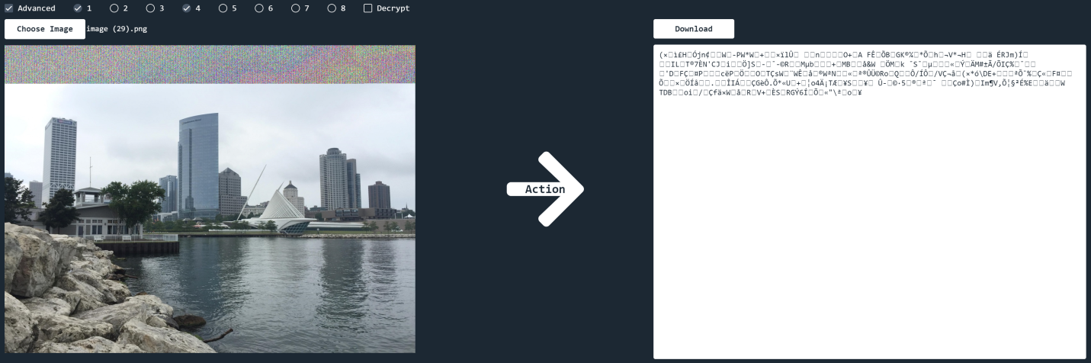

*Figure 5.8 Extract – Wrong Bits Chosen*

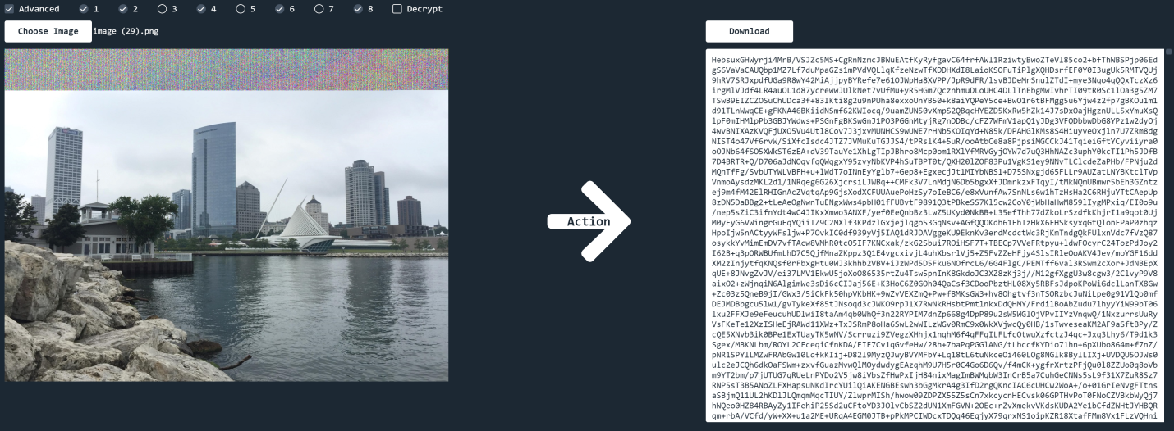But even if the steganographic key is set correctly, if there is no decryption key, the message will not be understood:

*Figure 5.9 Extract – Correct Bits Chosen, No Decryption Key*

If both keys are correct, the message will be extracted as a whole understandable text. Therefore, an 8-bit key (for extracting) and a 256-bit key (for decrypting) can secure the data, even if it can be noticed.

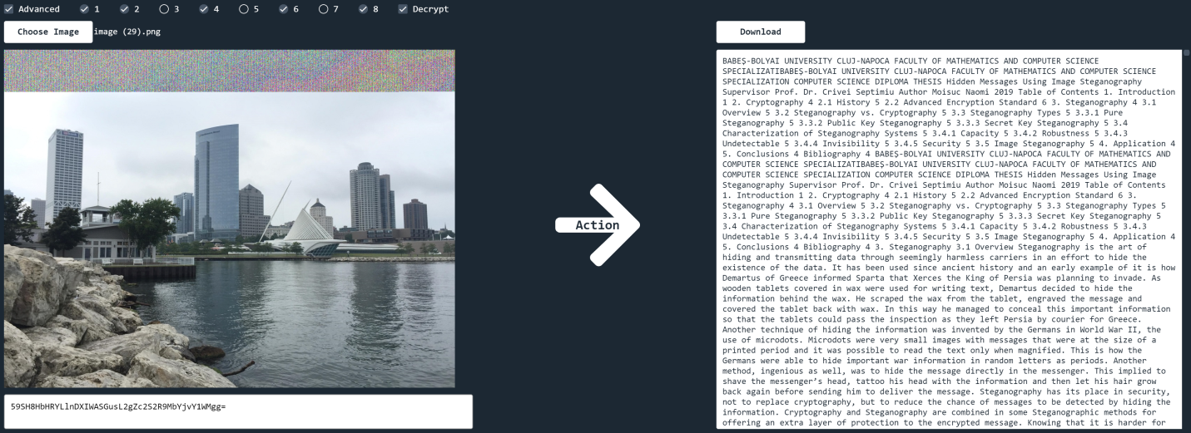

*Figure 5.10 Extract – Correct Keys*

**6. Conclusions and Real-World Applications**

Security is everywhere and yet, nowhere. The main goal of Steganography and Cryptography is not to completely secure data, but to increase, even in small quantities, the security of it. This paper also tries to add its contribution to this process by proposing an 8-bit steganographic key that can be used in the embedding and extraction processes. Combining Image Steganography with an 8-bit key and Cryptography with a 256-bit key, one can obtain stronger results.

In addition to this, the application presented in this paper could be used for securing important information such as personal data or bank account details. Even if every company that respects itself is secure for now, Cryptonos could still add its value to it, because nothing is ever secure enough.

A future improvement of the application would be to find an algorithm that spreads out the used pixels in a way that they are not in a sequence. The chosen bits on which the data is hidden might provoke visible changes to the image, which can be noticed by the naked eye. But if the used pixels are not in the same place, the human eye might not see the alteration being so obvious. Small alteration in one place might be more visible than bigger alteration in random places.

Another improvement would be to not use the pixels from the beginning of the image because in this way the header will be altered. There are applications that can detect that something is wrong with these altered images and the goal would be to make it unnoticeable. For example, images modified by Cryptonos cannot be sent via Skype or opened using Photoshop.

**Bibliography**

[1] .*NET Framework,* <https://dotnet.microsoft.com/learn/dotnet/what-is-dotnet>

[2] A.W. Naji, A.A. Zaidan, B.B. Zaidan, Shihab A. Hameed and Othman O. Khalifa, *Novel Approach for Secure Cover File of Hidden Data in the Unused Area within EXE File Using Computation between Cryptography and Steganography*, IJCSNS International Journal of Computer Science and Network Security, VOL. 9, No. 5, May 2009

[3] *Advanced Encryption Standard*, TutorialsPoint, <https://www.tutorialspoint.com/cryptography/advanced_encryption_standard.htm>

[4] *AES Encryption/Decryption using Arduino Uno*, 9 July 2017, <https://www.arduinolab.net/aes-encryptiondecryption-using-arduino-uno/>

[5] Alfred J. Menzes, Paul C. Van Oorschot and Scott A. Vanstone, *Handbook of Applied Cryptography*, CRC Press, October 1996

[6] *Angular Framework,* <https://angular.io/guide/architecture>

[7] *Block Cipher*, Techopedia, <https://www.techopedia.com/definition/16064/block-cipher>

[8] Margaret Rouse, Kathleen Richards and Borys Pawliw, *Cryptography from Search Security*, <https://searchsecurity.techtarget.com/definition/cryptography>

[9] Peter Smirnoff and Dawn M. Turner, *Symmetric Key Encryption – why, where and how it’s used in banking,* 18 January 2019, <https://www.cryptomathic.com/news-events/blog/symmetric-key-encryption-why-where-and-how-its-used-in-banking>

[10] *Symmetric vs. Asymmetric Encryption – What are differences?* <https://www.ssl2buy.com/wiki/symmetric-vs-asymmetric-encryption-what-are-differences>

[11] TJ Van Toll*, What Is the Angular Framework and Why Should Developers Use It?*, 6 March 2017, <https://www.programmableweb.com/news/what-angular-framework-and-why-should-developers-use-it/analysis/2017/03/06>

[12] Ujjwal Swami, *What is Cipher | Types of Ciphers | Working of Cipher*, <https://www.headendinfo.com/what-is-a-cipher/>

[13] W. Bender, D .Gruhl, N. Morimoto, A. Lu*, Techniques for data hiding*, IBM Systems Journal, Vol. 35, 1996

[14] Wen-Long Xu, Chin-Chen Chang, Tung-Shou Chen, Liang-Min Wang*, An Improved Least-Significant-Bit Substitution Method Using the Modulo Three Strategy*, 2016, <http://msn.iecs.fcu.edu.tw/~ccc/profile/publish/ij_paper/20161115_An%20Improved%20Least-Significant-Bit%20Substitution%20Method%20Using%20the%20Modulo%20Three%20Strategy.pdf>

[15] Zaidoon Kh. Al-Ani, A.A. Zaidan, B.B. Zaidan and Hamdan O. Alanzi, *Overview: Main Fundamentals for Steganography*, Journal of Computing, Volume 2, Issue 3, March 2010